
ATAR HUMAN BIOLOGY – UNIT 1
TASK 4 –DIGESTIVE AND EXCRETORY SYSTEMS TEST

NAME: _________________________________ WEIGHTING: 5 %
DUE DATE: _________________________________ MARK: ______ / = ______ %

Important Information for Students
- There are THREE sections in this test - Multiple Choice, Short Answer and Extended Answer.
- This is a closed-book assessment (no notes are allowed)
- The time allowed to complete the test is 55 minutes.
- Write your answers to the Multiple Choice section on the separate answer sheet provided.
- Write your answers to the Short Answer section in space provided.
- Write your answers to the Extended Answer section in space provided.

Sections | Marks Allocation | Your Total
A - Multiple Choice | 10
B - Short Answer | 32
C - Extended Answer | 10
TOTAL | 52

ATAR HUMAN BIOLOGY UNIT 1

Multiple Choice Answer Sheet

Name: _____________________________

Answer all questions by circling the letter corresponding with the most correct answer.

1. A B C D

2. A B C D

3. A B C D

4. A B C D

5. A B C D
6. A B C D

7. A B C D

8. A B C D

9. A B C D

10. A B C D

SECTION A - Multiple Choice Questions (10 Questions – 10 Marks)

Answer all questions on the separate Multiple Choice Answer Sheet.

- Substances absorbed into the lacteals are transported to the:
- circulatory system.
- liver.
- lymph system.
- lungs.

- Emulsification of fat:
- is a form of mechanical digestion.
- is brought about by pancreatic lipase.
- requires an acidic environment.
- changes fat to a form that can be absorbed.

- The functions of the large intestine are to:
- digest carbohydrates and absorb water.
- absorb all nutrients vital to the body.
- produce enzymes to break down fibre.
- manufacture vitamins and absorb water.

- Which of the following describes the direction of blood flow through the kidney?
- renal artery, renal vein, afferent arteriole, efferent arteriole, peritubular capillaries
- renal vein, renal artery, afferent arteriole, efferent arteriole, peritubular capillaries
- renal artery, efferent arteriole, afferent arteriole, peritubular capillaries, renal vein
- renal artery, afferent arteriole, efferent arteriole, peritubular capillaries, renal vein

- The alimentary canal is classed as an excretory organ because:
- is excretes faeces.
- it excretes unused substances from the body such as fibre.
- it excretes waste products produced by the liver.
- it changes the food that enters our mouth and excretes what we cannot digest.

- What is the role of the kidney in the excretory system of mammals?
- To remove salt from the body and to keep water in the body.
- To remove water from the body and keep salt in the body.
- To remove nitrogenous waste from the body and maintain water levels in the body.
- To remove water from the body and maintain levels of nitrogenous substances in the body.

- Normally, concentrations of substances that are metabolically important to the body are:
- high in the glomerular filtrate but are only found in trace amounts in the urine.
- low in the glomerular filtrate but high in the urine.
- high in both the glomerular filtrate and the urine.
- low in both the glomerular filtrate and the urine.
- What part does the stomach play in protecting us from pathogenic bacteria?
- Its digestive enzymes attack any bacteria which may enter.
- The high temperature in the stomach denatures the enzymes which pathogenic bacteria contain.
- The mucus produced by the gastric pits in the stomach traps bacteria.
- The low pH of the stomach generally kills most bacteria.

The table below shows the normal % composition of some components of blood plasma, fluid in the Bowman’s capsule and urine.
Component | Blood plasma | Bowman’s capsule | Urine
Urea | 0.03 | 0.03 | 2.00
Uric acid | 0.004 | 0.004 | 0.05
Glucose | 0.10 | 0.10 | None
Amino acids | 0.05 | 0.05 | None
Minerals | 0.72 | 0.72 | 1.50
Proteins | 8.00 | none | none

- Why is there a large amount of protein found in the blood but none in the capsule or urine?

- The proteins are converted to amino acids before they enter the capsule.
- The proteins are too large to move through the capsule membrane.
- The proteins are needed by the body and so are not filtered.
- The proteins are converted by the capsule into amino acids.

10. Which of the following is NOT a function of saliva?
- Initial digestion of proteins.
- Lubrication of the mouth.
- Initial digestion of carbohydrates.
- Lubrication of food.

SECTION B – Short Answer Questions ( 9 Questions – 32 Marks)

- Label the indicated parts on the diagram of the alimentary canal shown. (3 marks)

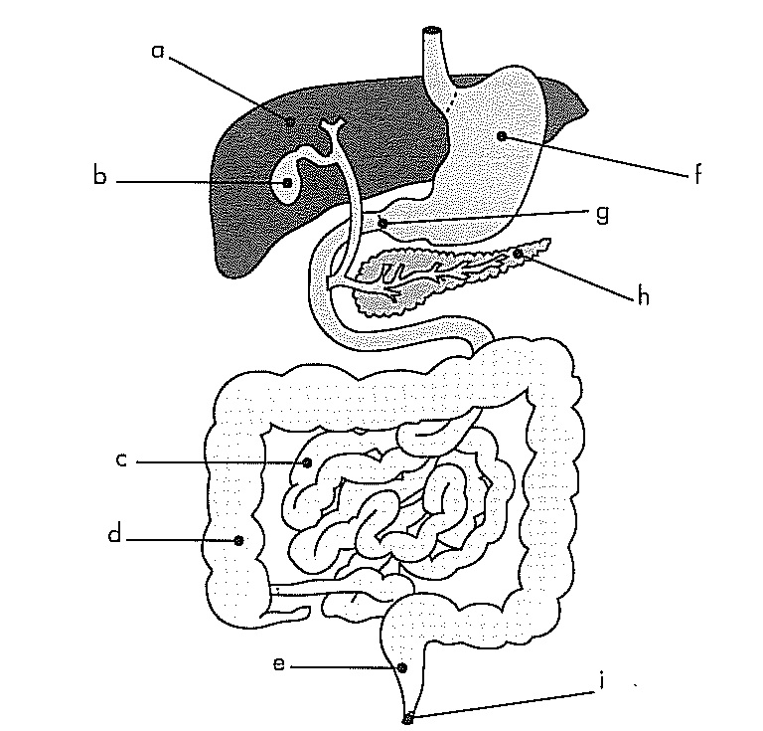
a: liver

b: gall bladder

e: rectum
f: stomach

g: pyloric sphincter

h: pancreas

- Explain why mechanical digestion is a vital part of the digestion process? (2 marks)
Food needs to be broken into smaller pieces so chemical digestion can occur
larger surface area to attack, making digestion more efficient

- State one complication that could occur if “g” did not work properly? (1 mark)
Food would enter duodenum only partially digested, would not be digested enough for absorption to take place OR
Acid from stomach may damage the lining of the duodenum

4. Discuss using examples, how diet can affect the functioning of the digestive system.(3 marks)
No vitamins or minerals to make digestive enzymes work
No fibre in diet so peristalsis does not occur
Too much fat so go through too quickly causing diarrhoea
Not enough glucose to make energy to make ATP for peristalsis Anything suitable (1)

- Complete the table below, summarising chemical digestion in the alimentary canal. (5 marks)

Dietary Nutrient | Enzyme | Nutrient to be absorbed | What part/s of the alimentary canal does this chemical digestion occur in?
Eg starch | amylase | Glucose/sugar/ monosaccharide | Mouth, small intestine
Protein | protease | Amino acids | Stomach, small intestine
Fat | Lipase | Fatty acids & glycerol | Small intestine
Half a mark each, must have all parts for last column

- Discuss how fatty acids are absorbed into the blood stream from the small intestine; include structures of the small intestine and how they maximise the process of absorption and processes involved. (6 marks)
Fatty acids arrives in small intestine – villi/microvilli slow down food to ensure longer time for absorption
Small intestine very long so more time for absorption
Villi and microvilli increase the surface area for absorption to take place
Villi one cell thick so small distance for fatty acid to go to get into lacteal
If fatty acid high in concentration in small intestine and low in lacteal will pass in by diffusion
Fatty acids will pass into villi and form fat before passing into lacteal
Continuous blood flow in lacteal maintains gradient for diffusion
Because millions of villi, more places for absorption.

- Refer to the diagram below of the kidney nephron and associated blood vessels.
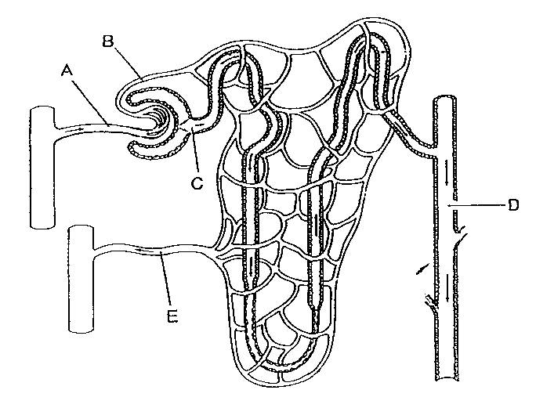

Outline three reasons why the nephron is suited to its function. (3 marks)
Very long so plenty of time for reabsorption
Bowmans capsule surrounds the glomerulus closely so maximum filtrate absorbed
Allows for controlled reabsorption of nutrients
Has several different parts each with a specific function to maximise reabsorption of all essential nutrients
Close proximity with capillary to ensure maximum reabsorption of nutrients
Constant blood flow to maximise diffusion of nutrient out/reabsorbed

- Urea is a toxic waste product that is produced by normal processes in the human body. Explain how urea comes to be present in the body (3 marks)
Deamination (1) or
Protein broken down by enzymes to amino acids.
Amine group (NH2) removed from amino acid and joined to hydrogen to make ammonia (NH₃) or
Amino acid + oxygen → ammonia + carbohydrate (1)
Ammonia toxic so converted to urea or
Ammonia + energy + carbon dioxide → urea + water (1)

9. At any given time, the liver contains 10% of the total blood in the body and it filters around 1.4L/min.
Discuss the role of the liver in both the digestive and excretory systems and how these systems are linked together. (6 marks)

Liver makes/breaks down protein to produce bile pigments or bile salts (1)
Bile stored in gall bladder and then added to the duodenum (1)
to emulsify fat so the fat can then be digested (1)
Liver breaks down dead red blood cells/haemoglobin (1)
give faeces characteristic brown colour/excreted as faeces (1)
Liver carries out deamination and produces urea from toxic waste product ammonia (1)
Urea sent to kidney where it is excreted as part of urine (1)
Detoxifies alcohol/drugs/hormones which are excreted (1)

SECTION C – Extended Answer Question (1 Question – 10 Marks)
Your response to this question should be written in paragraph form, but can refer to labelled diagrams in support.

The nephron is the primary structure concerned with the formation of urine. It is composed of a number of parts, including the:
  - Glomerulus
  - Proximal convoluted tubule
  - Distal convoluted tubule
  - Collecting duct
Discuss the role played by each of these nephron parts in the formation of urine. (10 marks)

Glomerulus
Filtration takes place here (1)
Blood comes in under pressure and the plasma is forced out into the capsule and collected into the Bowmans capsule = filtrate (1)
Filtrate contains liquid and nutrients such as glucose, potassium, chloride, amino acids, water etc and does not contain RBC,WBC, platelets or proteins (1)

PCT
Some nutrients reabsorbed from the nephron into the peritubular capillaries (1)
Nutrients diffuse into the capillaries or by active transport depending on the gradient (1)
What is left in nephron goes on to make urine (1)
Nutrients reabsorbed – sodium, water, glucose, urea, amino acids etc (must name three) (1)

distal convoluted tubule
Tubular secretions (1)
Potassium, hydrogen ions, urea and creatinine removed from blood and put into the nephron (1)
Can be active or passive transport (1)
Reabsorption of water control by hormones effect on the DCT(1)

Collecting Duct
Substance left in the nephron drain into collecting duct called urine (1)
taken to ureter/pelvis of kidney to then form urine in the bladder (1)

Maximum three marks per part

